**CoogSoft 2nd Gameplay Test Document**

**Ascension – Error 405**

**Fun Factor:**

* New enemies in 2nd floor are fun

**Glitches/Issues:**

* 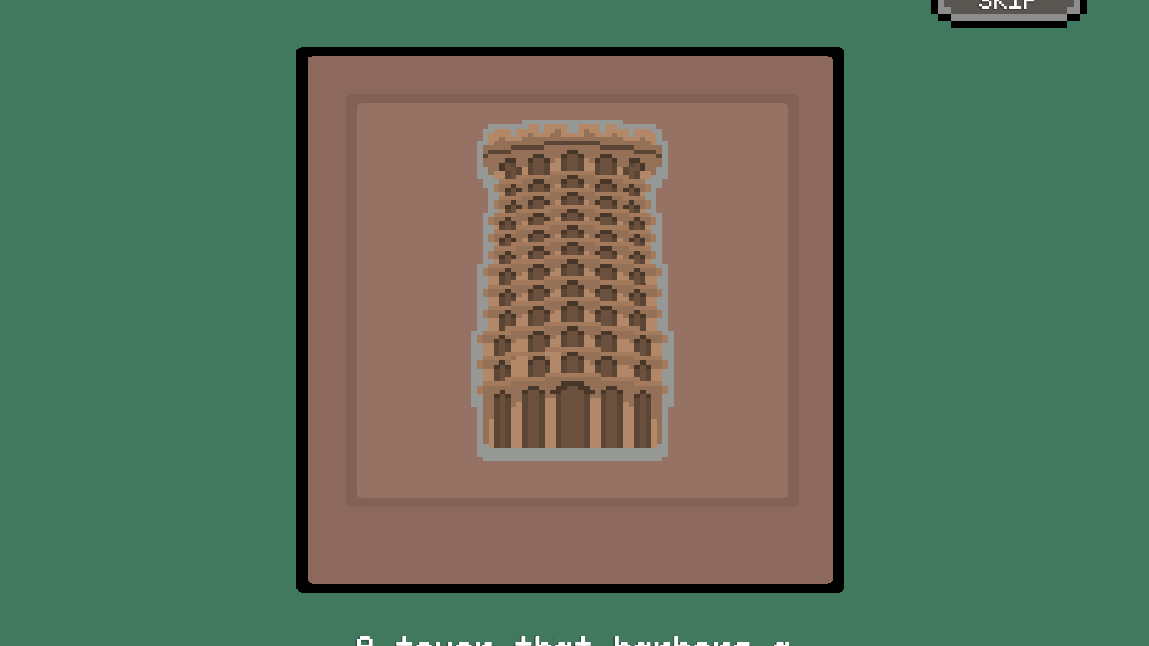 ui cut off in starting cutscene
* 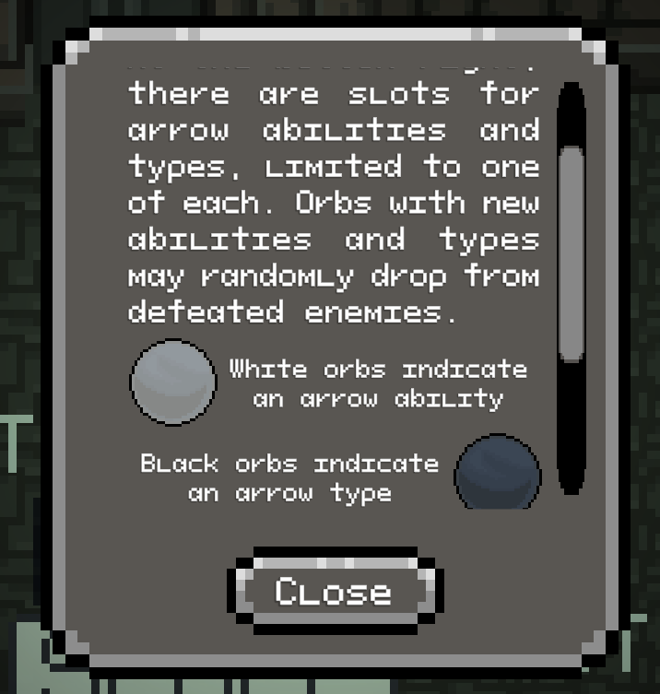 scrolling on this menu doesn’t always register/doesnt scroll that much
* Slimes after 1st level do not subtract from the 4 enemies left and suggest you add another interactable sign that explains what the next steps are (doors were confusing with the teleporting back
* 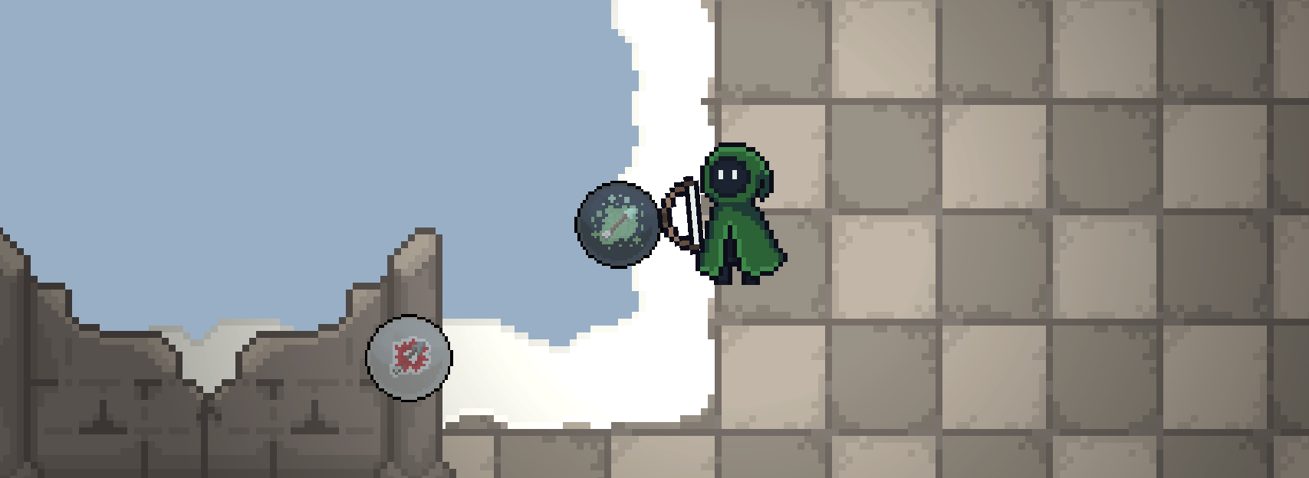 drops from birds too far to reach and cause player to fall off the map

**Suggestions:**

* Pressing tab or something will bring up text next to the arrow UI to read out the upgrades the player currently has
* Not clear which doors are “unlocked”/locked. Could make it more obvious with indicators or a pop up that shows up when trying to enter before defeating all enemies in level (was confusing in the level with the doors and slimes, didn’t know what I was supposed to do and when the doors were accessible)
* 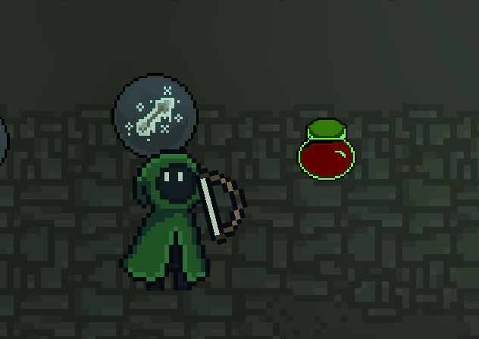 green healing looked poisoned, could make the normal 1 heart refill be the same bottle, just with less liquid
* Change the cursor to be a pixelated crosshair to match the game aesthetic
* Make the cursor stuck to the application, kept clicking out of the game